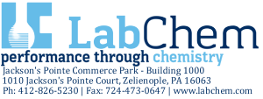

CERTIFICATE OF ANALYSIS
Description: POTASSIUM HYDROXIDE, 0.1N (0.1M) in IPA
Mfg. Date: 12/09/2019
Catalog Number: LC19550
Exp. Date: 06/09/2021
Lot Number: J340-02

ANALYTICAL SECTION
Test | Specification | Test Result
Appearance | clear, colorless to yellow solution | Pass Test
Normality | 0.1000N +/- 0.0005N | 0.0996N
Traceable to NIST | Potassium Hydrogen Phthalate | 84L
Intended Use - Product is intended for use in manufacturing procedures and laboratory procedures and protocols.
Storage Information - Unless otherwise noted on the product label, store the product under normal lab conditions in its tightly closed, original container. Do not pipet directly from the container or return unused portions to the container.
Instructions for Handling and Use - Please refer to the associated product label and Safety Data Sheet (SDS) for information regarding safety and handling of this product.
Preparation - All products are manufactured and tested according to established, documented procedures and methodology. Production documentation records manufacturing data, raw material traceability and testing history on a per lot basis. Balances, thermometers, and glassware are calibrated before first use and on a regular schedule with references traceable to NIST standards.
Submitted by: Greg Albright, Chemist Supervisor
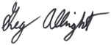
An ISO9001:2015 certified company. Registration # 0306-0104/22/2021 10:44 AM
Form #17.13 07/28/2016

